

Discovering
Church Commitment

CC1

Welcome To
Discovering Church Commitment

We’re glad you’ve chosen to find out more about THE CORNERSTONE! This class is the basic introduction to our church family. Since we have members from many different church backgrounds, this class was designed to clearly explain who and what our church is.

Discovering Church Commitment is divided in four sessions of 25 minutes each.

The Basics For This Class

“...You are a member of God’s very own family...and you belong in God’s household with every other Christian.” Eph. 2:19

Key Truths:

1. The church is ________________________

2. God expects you to be______________________ of a church family.

3. A Christian without a church family is___________________________

The Goal Of This Class

...That I will commit myself to___________ and to the______ _____

What Makes THE CORNERSTONE A Family?

Four things unite us:

• Our _______________ (What God has done for us)

• Our _______________ (Why we exist as a church)

• Our _______________ (How we fulfill our purpose)

• Our _______________ (When and where we fulfill our purpose)

Session One

THE CORNERSTONE Strategy

(Paul) “I have been all things to all sorts of people that by every possible means I might win some to God. I do all of this for the sake of the Good News.”

1 Corinthians 9:22-23

Who Are We Trying To Reach?

“...Yes, whatever a person is like, I try to find common ground with him so he will let me tell him about Christ and let Christ save him.” 1 Cor. 9:22

5 Circles of Commitment

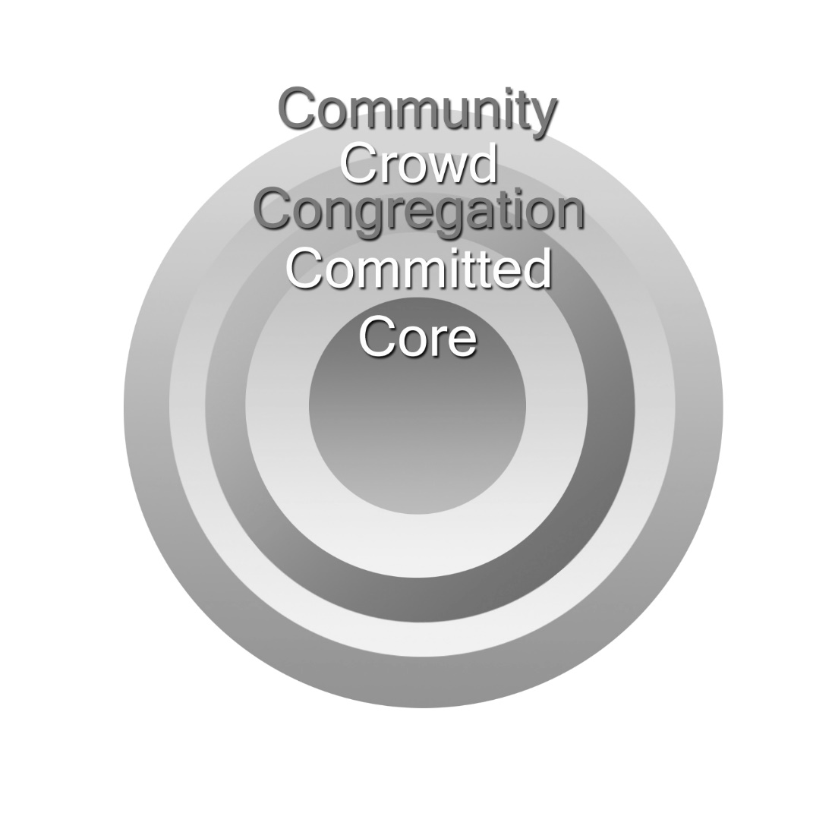
THE CORNERSTONE’s objective is to keep moving people toward the center by encouraging personal spiritual commitments. Specifically, we call people to four basic commitments:

The Four Cornerstone Covenants:

1. The Membership Covenant...

is a commitment to ________________and _________________

“You are members of God’s very own family...and you belong in God’s household with every other Christian.” Eph. 2:19

“We are all parts of Christ’s Body, and it takes every one of us to make it complete, for we each have different work to do. So we belong to each other and need all the others.” Rom. 12:4-5

2. The Maturity Covenant...

is a commitment to the__________________necessary for spiritual growth?

“Continue to grow in grace and knowledge of our Lord and Savior Jesus Christ.” 2 Peter 3:18

“Take the time and trouble to keep yourself spiritually fit.” 1 Tim. 4:7

3. The Ministry Covenant...

is a commitment to discovering and using my God-given gifts/abilities in _______________God and others.

“God has given each of you some special abilities; be sure to use them to help each other...” 1 Pet. 4:10

“There are different kinds of service to God...together you form the Body of Christ and each one of you is a necessary part of it.” 1 Cor. 12:5,27

4. The Missions Covenant...

is a commitment to ______________________________the Good News with others.

“...you will be my witnesses for me...to the ends of the earth.” Acts 1:8

We are a Mission-hearted church. We believe that a Church that does not believe in Missions is not a thriving Church. We want to impact not just our community but the world!

Why do we have these covenants?

We Become What We Are__________________________

The CORNERSTONE Strategy
3 Intentional Focuses of Our Ministry

Multi-__________– Displaying an acceptance of all cultures and ethnicities.
Using culture to embrace and not using culture to divide.

Multi-__________ – Bridging the generations by serving together and serving one another. Promoting to serve the generation prior. For Example: Youth serving/discipling the Children’s MinistryCollege/young adults serving/discipling the YouthAdults serving/discipling the College/Young AdultsElders serving/discipling adults/families Pastors and Senior leaders serving/discipling all. We are called to promote unity on every level and encourage all ages to serve.

Multi-_____________ – Building a strong church by encouraging and utilizing their Spiritual and GOD given gifts to build up the body. The personality of the church shines when the Pastors and Leaders cultivate the specific, unique gifting of all of the generations to be exercised. This occurs when people commit to being discipled through our discipleship groups, leadership and ministry training sessions and advancement with our commitment courses.

Session Two

THE CORNERSTONE
Structure

“For God is not a God of disorder, but of peace...
Everything should be done in a fitting and orderly way.”

1 Cor. 14:33,40

How Our Church Is Structured

The structure of the church should not be determined by culture, business practices, or even denominational traditions.

The nature of the church determines its structure.

I. The Church Is A_________________________

“They continued steadily learning the teaching of the apostles, and joined in the fellowship...” Acts 2:42

A top priority in a fellowship is___________________ and _____________________

“Make every effort to keep the unity of the Spirit through the bond of peace.” Eph. 4:3

“So let us concentrate on the things that make for harmony and the growth of our fellowship together.” Rom. 14:19

ANY attitude that causes disunity is sin.

Col. 3:15, 1 Cor. 1:10, 2 Tim. 2:14, Pr. 17:14, 2 Cor. 13:11,
Phil. 1:27, 2:1-3, Col. 2:2, Phil. 4:2, 1 Peter 3:8, 1 Cor. 14:33,
John 13:34-35, 2 Tim. 2:23, Rom. 15:5-6, Rom. 12:16-18,
Col. 3:13-14, Ps. 133:1

Implication: A good structure promotes unity and downplays_______________________

“(Often)...your meetings do more harm than good because I hear that when you come together as a church, there are divisions among you...” 1 Cor. 11:17-18

II. The Church Is A___________________________

“You should be like one big happy family, full of sympathy toward each other, loving one another with tender hearts and humble minds.” 1 Peter 3:8
Gal. 6:10, Heb. 2:10-12, 1 Peter 4:17

So we operate on the basis of__________________ not_____________________

“Don’t reprimand a senior member of the church, appeal to him as a father. Treat the young men as brothers, and the older women as mothers. Treat the younger women as sisters...” 1 Tim. 5:1-2

“(A Pastor) must manage his own family well and see that his children obey him with proper respect. If anyone does not know how to manage his family, how can he take care of God’s church?” 1 Tim. 3:4-5

III. The Church Is A_________________________________________

1 Cor. 12:27, Eph. 5:23, Eph. 1:22-23, Col. 1:18, 2:19
We are a body — not a business!
We are an organism — not an organization!

Therefore, we function on the basis of_____________________________ not__________________

“Just as each of us has one body with many members, and these members do not all have the same function, so in Christ we who are many form one body, and each member belongs to all the others. We each have different gifts according to the grace given us.” Rom. 12:4-6

In an organization, “maintenance” becomes the focus. But in an organism, “ministry” is the focus.

At THE CORNERSTONE we have a simple structure so we can maximize______________________and minimize____________________________

“God gave...some to be pastors and teachers to prepare God’s people for works of ministry, so that the body of Christ may be built up...” Eph. 4:11-12
Our Structure

• The people are the “_______________”.

• The pastors are the “______________________”.

IV. The Church Is A________________________________________

(Jesus’ favorite description of the church)
John 10:1-30, Matt. 26:31, Matt. 25:33

Therefore, it is cared for and led by___________________________

“Jesus asked Simon Peter, ‘Do you really love me?’ ‘Yes Lord,’ said Peter. ‘Then take care of my sheep.’” John 21:16-17

Three different terms are used in the New Testament to refer to the same church leaders:
• “POIMEN”
• PRESBUTEROS”
• EPISCOPOS”

“To the elders I say...Be shepherds of God’s flock, serving as overseers...” 1 Pet. 5:1-2
“Paul sent to Ephesus for the elders of the church. When they arrived he said to them... Guard yourselves and all the flock of which the Holy Spirit has made you overseers. Be pastors of the church of God...” Acts 20:17-18, 28

Session Three

THE CORNERSTONE Statements

“Let there be real harmony among you so there won’t be any split in the church. I plead with you to be of one mind, united in thought and purpose.”

1 Corinthians 1:10

THE CORNERSTONE
VISION STATEMENT

WE ARE CALLED to reach out to all people
from all walks of life with the grace and love
of JESUS CHRIST.

Our Purpose Statement
Why We Exist As A Church

The purpose of our church is summarized in a single sentence based on two key scriptures:

“We believe a great commitment to the great________________________ and the

great___________________will grow a great church!”

The Great Commandment: “Jesus said, ‘Love the Lord your God with all your heart...soul...and mind. This is the first and greatest commandment. And the second is like it: Love your neighbor as yourself. All the Law and Prophets hang on these two commandments.’” Matt. 22:36-40

The Great Commission: “Jesus said, ‘Go and make disciples of all nations, baptizing them in the name of the Father and of the Son and of the Holy Spirit, and teaching them to obey everything I have commanded you.” Matt. 28:19-20

• To “Love God with all your heart” is “____________________”.

• To “Love your neighbor as yourself” is “_________________”.

• To “Go...make disciples” is “___________________”.

• To “Baptize...” is to “INCORPORATE INTO ___________________”.

• To “Teach them...all things” is “___________________”.

THE CORNERSTONE Church Exists:

1. To_______________ God’s Presence (Worship)

2. To_________________ God’s Love (Ministry)

3. To_________________ God’s Word (Evangelism)

4. To______________________________ God’s Family (Fellowship)

5. To____________ God’s People (Discipleship)

I. We Exist To Celebrate God’s Presence

Worship: __________________________________________

“Worship the Lord your God, and serve Him only.” Matt. 4:10

“...The Father seeks worshipers...and His worshippers must worship Him in spirit and in truth.” Jn 4:23-24

Expressions of Worship

• Singing (Eph. 5:19)
• Commitment (Romans 12:1-2)
• Praying (Ps. 95:6)
• Hearing the Word (John 17:17)
• Giving (1 Cor. 16:1-2)
• Baptism (Romans 6:3-4)
• Meditating (Hab. 2:20)
• Communion (1 Cor. 11-23-26)

CORNERSTONE Worship Style

“Celebration”  Psalm 122:1 | “Inspiration”  Isaiah 40:31 | “Preparation”  Eph. 4:11-12

II. We Exist To Communicate God’s Word

Evangelism: _____________________________________________

“His intent was that through the church, the manifold wisdom of God should be made known...” Eph. 3:10

“Anyone who calls on the name of the Lord will be saved. But who can ask Him to save them unless they believe in Him? And how can they believe in Him if they have never heard about Him? And how can they hear about Him unless someone tells him?” Rom. 10:13-14 (LB)

Why Our Church Must Never Stop Growing

1. Because___________________________________

“The Lord...is patient, not wanting anyone to perish, but wants everyone to come to repentance.” 2 Pet. 3:9

2 Cor. 5:14, Luke 15:3-10, Matt. 9:12-13

2. Because_____________________________________

“Go out into the country...and urge anyone you find to come in, so that My House will be full.” Luke 14:23
“...you will be my witnesses...” Acts 1:8

3. Because__________________________________________________

“Under Christ’s control, the whole Body is nourished...and grows as God wants it to grow.” Col. 2:19

“(Jesus) I will build my church.” Matt. 16:18

Unbiblical Excuses For Not Growing:

• “God isn’t interested in numbers.”
• “Our church wants quality not quantity.”
• “Large churches are impersonal”

We believe our church must grow____________________ and ___________________at the same time.

“And the Good News of the Kingdom will be preached to the whole world as a testimony to all nations, and THEN the end will come.” Matt. 24:14

III. We Exist To Educate God’s People

Discipleship: BECOMING _____________________________

“Let us leave the elementary teachings about Christ and go on to maturity...” Heb. 6:1

“Grow in grace and knowledge of our Lord Jesus Christ.” 2 Peter 3:18

“(God has given)...some to be pastors and teachers, to prepare God’s people for works of ministry, so that the Body of Christ may be built up until we all...become mature...like Christ.” Eph. 4:11-13

More will be details will be covered in
Discovering Spiritual Maturity CLASS #201

IV. We Exist To Demonstrate God’s Love

Ministry: MEETING NEEDS WITH ______________

“By this shall all men know that you are my disciples — that you have love for one another.” John 13:35

1 John 3:16-17, Matt. 25:34-40, Heb. 13:16, Rom. 12:13

The heartbeat of THE CORNERSTONE is our _____________________________
Every member needs to be a part of one.

“Now God gives us many kinds of special abilities.. and there are different kinds of service to God (ministry)... All of you together form the one Body of Christ and each of you is a separate and necessary part of it.” 1 Cor. 12:4-5, 27

At THE CORNERSTONE...

• Every member is a:___________________
• Every task is:________________________
• Every member is a “great” in:_____________________
Our Statement of Faith
What We Believe

• In essential beliefs — we have unity.
“There is one Body and one Spirit...there is one Lord, one faith, one baptism, and one God and Father of us all...” Eph. 4:4-6

• In non-essential beliefs — we have liberty.
“Accept him whose faith is weak, without passing judgment on disputable matters... Who are you to judge someone else’s servant? To his own master he stands or falls... So then each of us will give an account of himself to God... So whatever you believe about these things keep between yourself and God.” Romans 14:1,4,12,22

• In all our beliefs — we show charity.
“...If I hold in my mind not only all human knowledge but also the very secrets of God, and if I have the faith that can move mountains — but have no love, I amount to nothing at all.” 1 Cor. 13:2

The Essentials We Believe:

1. About God

God is the Creator and Ruler of the universe. He has eternally existed in three personalities: the Father, the Son, and the Holy Spirit. These three are co-equal and are one God.

Genesis 1:1,26,27, 3:22; Psalm 90:2; Matthew 28:19;
1 Peter 1:2; 2 Corinthians 13:14

2. About Jesus Christ

Jesus Christ is the Son of God. He is co-equal with the Father. Jesus lived a sinless human life and offered Himself as the perfect sacrifice for the sins of all people by dying on a cross. He arose from the dead after three days to demonstrate His power over sin and death. He ascended to Heaven’s glory and will return again someday to earth to reign as King of Kings, and Lord of Lords.

Matthew 1:22, 23; Isaiah 9:6; John 1:1-5; 14:10-30;
Hebrews 4:14,15; 1 Corinthians 15:3,4; Romans 1:3,4;
Acts 1:9-11; 1 Timothy 6:14,15; Titus 2:13

3. About the Holy Spirit

The Holy Spirit is co-equal with the Father and the Son of God. He is present in the world to make men aware of their need for Jesus Christ. He also lives in every Christian from the moment of salvation. He provides the Christian with power for living, understanding of spiritual truth, and guidance in doing what is right. He give every believer a spiritual gift when they are saved. As Christians, we seek to live under His control daily.

2 Corinthians 3:17; John 16:7-13, 14:16,17; Acts 1:8;
1 Corinthians 2:12, 3:16; Ephesians 1:13; Galatians 5:25;
Ephesians 5:18
4. About the Bible

The Bible is God’s Word to us. It was written by human authors, under the supernatural guidance of the Holy Spirit. It is the supreme source of truth for Christian beliefs and living. Because it is inspired by God, it is the truth without any mixture of error.

2 Timothy 3:16; 2 Peter 1:20,21; 2 Timothy 1:13;
Psalm 119:105,160, 12:6; Proverbs 30:5

5. About Human Beings

People are made in the spiritual image of God, to be like Him in character. People are the supreme object of God’s creation. Although every person has tremendous potential for good, all of us are marred by an attitude of disobedience toward God called “sin”. This attitude separates people from God and causes many problems in life.

Genesis 1:27; Psalm 8:3-6; Isaiah 53:6a; Romans 3:23; Isaiah 59:1, 2

6. About Salvation

Salvation is God’s free gift to us but we must accept it. We can never make up for our sin by self-improvement or good works. Only by trusting in Jesus Christ as God’s offer of forgiveness can anyone be saved from sin’s penalty. When we turn from our self-ruled life and turn to Jesus in faith we are saved. Eternal life begins the moment one receives Jesus Christ into his life by faith.

Romans 6:23; Ephesians 2:8,9; John 14:6, 1:12; Titus 3:5;

Galatians 3:26; Romans 5:1
7. About Eternal Security

Because God gives us eternal life through Jesus Christ, the true believer is secure in that salvation for eternity. If you have been genuinely saved, you cannot “lose” it. Salvation is maintained by the grace and power of God, not by the self-effort of the Christian. It is the grace and keeping power of God that gives us this security.

John 10:29; 2 Timothy 1:12; Hebrews 7:25, 10:10,14; 1 Peter 1:3-5

8. About Eternity

People were created to exist forever. We will either exist eternally separated from God by sin, or eternally with God through forgiveness and salvation. To be eternally separated from God is Hell. To be eternally in union with Him is eternal life. Heaven and Hell are real places of eternal existence.

John 3:16; John 14:17; Romans 6:23; Romans 8:17-18;
Revelation 20:15; 1 Cor. 2:7-9

Our Lifestyle Statement
What We Practice

Beliefs are not worth much unless they are translated into actions. Based on what the Bible teaches, we feel very strongly about the following seven practices:

Bible As Our Sole Authority

“The whole Bible was given to us by inspiration from God and is useful to teach us what is true and make us realize what is wrong in our lives; it straightens us out and helps us to do what is right.” 2 Tim. 3:15

Since God’s Word is the only completely reliable and truthful authority, we accept the Bible as our manual for living. Our first question when faced with a decision is “What does the Bible say?” We practice daily Bible reading, Bible study, and Bible memorization. The Bible is the basis for all we believe.

Autonomy of Each Local Church

“Christ is the head of His Body, the church. He is the source of the Body’s life...” Col. 1:18 (GN)

Christ is the recognized head of our church, not any person, group, or religious organization. While recognizing the value of associating and cooperating with other groups of Christians, we believe every local church should be self-governing and independent from any denominational control.

Priesthood of Every Believer

“Christ loves us, and by His death He has freed us from our sins and made us a kingdom of priests to serve God...” Rev. 1:6 (GN) “You are...the King’s priests...God’s own people, chosen to proclaim the wonderful acts of God.” 1 Pet. 2:9 (GN)

The Bible teaches that every Christian is called to “full time” Christian service, regardless of his or her vocation. We practice the truth that every believer is a minister by encouraging every member to find a place of service and
ministry. Every believer has direct access to God through prayer Bible reading.

Tithing

“A tithe of everything you produce belongs to the Lord; it is holy to the Lord.” Lev. 26:30

At THE CORNERSTONE we practice tithing for the support of Christ’s body, the church, as God commands. We recognize that giving 10% of our income is the Biblical standard of giving.

WHAT IS THE DIFFERENCE BETWEEN A "TITHE" AND AN "OFFERING"?

•A “tithe” is giving FIRST 10TH of my income. Honoring Him with our first fruits. This shows obedience, trust and opens the door for GOD to continue to provide and bless us freely for our obedience.

•An “offering” is anything I give in addition to my tithe.

WHERE SHOULD I GIVE MY TITHE?
WHERE I WORSHIP. "Bring your whole tithe to My Storehouse (Temple) ..." Mal. 3:10

Immersion

“For when you were baptized, you were buried with Christ, and in baptism you were also raised with Christ...” Col. 2:12

We practice baptism by immersion under water — the way Jesus was baptized, and the way the Bible commands.

Spirit-led Living

(Jesus said), “I am the Vine, you are the branches. If you abide in me and I in you, you will bear much fruit; but apart from me you can do nothing.” John 15:5

We believe the only way possible to live the Christian life is by God’s power within us. So we seek to practice a daily dependence on God’s Spirit to enable us to do what is right. (Phil. 2:13, Eph. 5:18)

Telling Others About Christ

“Always be prepared to give an answer to everyone who asks you to give the reason for the hope that you have.” 1 Peter 3:15

It is the responsibility of every Christian to share the Good News with those with whom God brings us into contact. We practice personal sharing about Christ and inviting friends to church.

Session Four

Our Salvation

“For now we are all children of God through faith in Jesus Christ, and we who have been baptized into union with Christ are enveloped by Him. We are no longer Jews or Gentiles, or slaves or free men, or even merely men or women, but we are all the same — we are Christians; we are one in Jesus Christ.”

Galatians 3:26-28

What Does It Mean To Be A Christian?

Most people live their entire lives without ever knowing “WHY?” They exist year after year with no idea of why they live or God’s purpose for their lives. The most basic question a person can ask is, “What is the meaning of life?”

Everyone wants to be happy. People try many ways:

...Some look for happiness by acquiring possessions.
...Some look for happiness by experiencing pleasure.
...Some look for happiness by gaining prestige & power.
Happiness fades. Happiness is temporal.

Happiness is based on_____________________. Joy is not based on circumstance. Joy is true _______________which comes through our ___________ and the eternal ___________ we have in JESUS CHRIST.

Joy comes from understanding my ___________________________________________

I. Why Am I Here?

1. God made me to________________________________me!

God says, “I have loved you with an everlasting love!” Jer. 31:3

“Even before the world was made, God had already chosen us to be His through our union with Christ...because of His love. God had already decided that through Jesus Christ He would make us His children — this was God’s pleasure and purpose.” Eph. 1:4-5

2. We were created to _________________a personal relationship with God and to ___

_______all of the rest of God’s creation! This makes us special!

“So God created human beings, making them in His image. He blessed them, and said,...live all over the earth and bring it under control. I am putting you in charge.” Gen. 1:27-28

“God richly provides us with everything for our enjoyment.” 1 Tim. 6:17

Jesus said, “I have come in order that you might have life — life in all its fullness!” John 10:10

3. When we know and love God, and live in harmony with His purpose for our lives, it produces tremendous benefits in our lives:

Clear Conscience  Rom. 8:1 | Life & Peace  Rom. 8:6 | Help with Weakness  Rom. 8:26
Purpose  Rom. 8:28 | Confidence  Rom. 8:31 | Security  Rom. 8:39
Power & Strength  Phil. 4:13 | Fulfillment  Phil. 4:19 | Freedom  John 8:32,36

II. What’s The Problem?

Man has a natural desire to_________________________due to _________________ and to ignore God’s principles for living.

“Look out for #1. Do your own thing.”
“If it feels good, do it - regardless of what God says about it.”
“It’s my life and I’ll do what I please!”

The Bible calls this attitude:_____________________________

“All of us, like sheep, have gone astray, and each of us has turned to his own way.” Isaiah 53:6

“If we say that we never sin, we are only fooling ourselves, and refuse to accept the truth.” 1 John 1:8

Sin breaks our close relationship with God. It causes us to fear God and try to live our lives outside of His will.

“The trouble is that your sins have cut you off from God.” Isaiah 59:2

“All have sinned and fall short of God’s glorious ideal.” Romans 3:23

When our relationship to God is not right, it causes PROBLEMS in every area of our lives — marriage, career, relationships, finances, etc.
WHEN PEOPLE HAVE PROBLEMS, THEY OFTEN TRY MANY DIFFERENT WAYS OF COPING BEFORE TURNING TO GOD.

“There are ways that SEEM right to man, but they only end in death.” Proverbs 16:25

Even when we know that our deepest need is God, we often try wrong ways of getting to know Him:

• “My mother was a Christian so...”
• “It doesn’t matter what you believe, just be sincere.”
• “I’ll give up all my bad habits.”
• “I’ll work real hard and earn it.”
• “I’ll be religious and go to church.”
III. What’s The Solution?

Jesus Christ said, “I AM THE WAY, the Truth, and the Life. No one comes to the Father, except THROUGH ME!” John 14:6

God Himself came to earth as a human being to bring us back to Himself. If any other way would have worked, Jesus Christ would not have had to come. The Way is a Person!

JESUS HAS ALREADY TAKEN CARE OF YOUR SIN PROBLEM!

“The wages of sin in death, BUT the gift of God is eternal life through Jesus Christ our Lord.” Rom. 6:23

God did this for us because He loves us and wants us to know Him.

“God demonstrated His love for us in that while we were still separated from God by sin, Christ died for us.” Rom. 5:8

“God is on one side and all people are on the other side, and Christ Jesus is between them to bring them together, by giving His life for all mankind.” 1 Tim. 2:5

God has already done His part to restore our relationship to Him. He took the initiative. Now He waits for each of us to individually accept what He has done for us.

IV. What Does God Want Me To Do?

1. ______________________ that God has not been first place in your life and ask Him to forgive your sins.

“If we confess our sins, He is faithful and just and will forgive us our sins and cleanse us from every wrong.” 1 John 1:9

2. ______________________that Jesus died to pay for your sins and that he rose again on the third day and is alive today.

“If you confess that Jesus is your Lord, and you believe in your heart that God raised Him from the dead, you will be saved.” Romans 10:9

“Salvation is found in no one else, for there is no other name (Jesus) by which we must be saved.” Acts 4:12

3. _ ______________________God’s free gift of salvation. Don’t try to earn it.

“For it is by grace you are saved, through faith — and this not from yourselves, it is the gift of God — not by works, so that no one can boast.” Ephesians 2:8,9

Our relationship to God is not restored by anything we do, but on the basis of what Jesus already did for

4. ____________________Jesus Christ to come into your life and be the director (“Lord”) of your life.

“To all who receive Him, He gives the right to become children of God. All we need to do is to trust Him to save us. All those who believe this are reborn! — not a physical rebirth...but from the will of God!” John 1:12-13

“Jesus says, ‘Listen! I stand at the door and knock. If anyone hears my voice and opens the door, I will come in...’” Rev. 3:30

You can take these steps by praying a simple prayer of commitment to God:

“Dear Jesus, I know that I am a sinner. Deserving of condemnation but because of Your great love for me, You came to pay the ultimate price. I repent of my sins and ask you to forgive me. I believe in my heart that you died on the cross for my sins and on the third day you rose again. I believe in my heart that you are JESUS CHRIST, the Lord and Savior of all and I receive your forgiveness and gift of salvation now. Please help me to grow now as a Christian. May Your Spirit lead me in all your ways. May Your truth Guide me all of my days. In the Most Precious Name of JESUS. Amen.

“Whoever calls upon the name of the Lord will be saved.” Romans 10:13
The Importance of Being Baptized

I. Why Should I Be Baptized?

1. To follow the example set by____ ______________________

“At that time Jesus came from Nazareth and was baptized by John in the river.” Mark 1:9

2. Because Christ ____ __________________it.

“Jesus said, ‘Go then, to all people everywhere and make them my disciples, baptize them in the name of the Father, the Son, and the Holy Spirit, and then teach them to obey everything I have commanded you.’” Matt. 28:19-20

3. It demonstrates that I really am a___ _____________________

“...many of the people who heard Him believed and were baptized.” Acts 18:8

“We know that we have come to know Him, if we obey His commands.” 1 John 2:3

II. What is the meaning of baptism?

1. It illustrates Christ’s______ ___________________ and resurrection

“Christ died for our sins... He was buried...and He rose again.” 1 Cor. 15:3-4

“For when you are baptized, you were buried with Christ, and in baptism you were also raised with Christ. Col. 2:12

2. It illustrates my_____ _______________________ as a Christian.

“When someone becomes a Christian he becomes a brand new person inside. The old life has passed away and a new life has begun!” 2 Cor. 5:17

“By our baptism then, we were buried with Him and shared His death, in order that, just as Christ was raised from the dead...so also we may live a new life!” Rom. 6:4

Baptism doesn’t make you a believer — it shows that you already believe. Baptism does not “save” you, only your faith in Christ does that. Baptism is like a wedding ring — it’s the outward symbol of the commitment you made in your heart.

“For it is by grace you have been saved, through faith...it is the gift of God — not by works, so that no one can boast.” Ephesians 2:8-9

III. Why Be Baptized By Immersion?

Because_____ __________________ was baptized that way.

“As soon as Jesus was baptized, He went up out of the water.” Matthew 3:16

Every baptism in the _________________was by immersion.

(Example) “...then both Philip and the man went down into the water and Philip baptized him. When they came up out of the water...” Acts 8:38-39

The word “Baptize” means to _____ _______________water”.

The Greek word baptizo means, “to immerse or dip under water”.

It best symbolizes a burial and resurrection!

IV. Who Should Be Baptized?

Every person who has _____ ___________________in Christ.

“Those who believed and accepted His message were baptized...” Acts 2:41

“Simon himself believed and was baptized...” Acts 8:13

“But when they believed Philip as he preached the Good News...and the name of Jesus Christ, they were baptized, both men and women.” Acts 8:12

At THE CORNERSTONE, we wait until our children are old enough to believe and understand the true meaning of baptism before we baptize them.

Some churches practice a “baptism of confirmation” for children. This ceremony is intended to be a covenant between the parents and God on the behalf of the child. The parents promise to raise their child in the faith until the child is old enough to make his own personal confession of Christ. This custom began about 300 years after the Bible was completed. This is different from the baptism talked about in the Bible, which was only for those old enough to believe. The purpose is to publicly confess your personal commitment to Christ.

At THE CORNERSTONE, it is a membership requirement that every member must have been baptized the way Jesus demonstrated, even though many of us were “confirmed” as children.

V. When Should I Be Baptized?

As soon as you have believed!

“Those who believed...were baptized...that day!” Acts 2:41

“Then Philip began with the scripture and told him the Good News about Jesus. As they traveled along the road, they came to some water, and the man said, ‘Look, here is water! Why shouldn’t I be baptized right now?’ Philip said, ‘If you believe with all your heart, you may.’ The man answered, ‘I believe that Jesus Christ is the Son of God.’ So they went down into the water and Philip baptized him.” Acts 8:35-38

There is no reason to delay. As soon as you have decided to receive Christ into your life, you can and should be baptized. If you wait until you are “perfect”, you’ll never feel “good enough”!

Can my family be baptized together?

Yes! If each family member understands fully the meaning of baptism, and each one has personally placed his/her trust in Christ for salvation, we encourage families to be baptized at the same time. It is a wonderful expression of commitment. Young children who wish to be baptized are asked to meet with our Minister of Children for a pre-baptism conversation.

However, it is important to remember that baptism is a personal statement of faith, not a family tradition. It is usually not wise to delay your baptism while waiting on other family members to accept Christ, particularly children. This puts an undue pressure on them, and delays your obedience.

What should I wear when I am baptized?

Women should wear shorts and a top or a “muumuu” style dress rather than a swimsuit. Men may wear a swimsuit. Bring a change of clothes, a towel, and a plastic bag for your wet clothes.

The Baptism
At the baptism location, One of the Pastors will first explain the meaning of baptism. When it is time for baptism, you will wait at the edge of the pool for your turn to be baptized. One of the Pastors will introduce you, ask if there is anything you would like to say, proceed with a declaration of faith (example: Because of Your commitment and faith to the LORD JESUS CHRIST, before GOD and your family and friends, I now baptize you in the name of the Father, Son and the Holy Spirit) then it will proceed with the baptism under the water, and then you can leave the pool, dry off, and watch the others. At a following service, you will be given a certificate of your baptism. We encourage you to invite all your relatives and friends to attend your baptism.

Special Needs?

All of our Pastors can perform a private baptism in special circumstances.

The Meaning of the Lord’s Supper

Jesus never asked His disciples to remember His birth. But He did instruct them to remember His death and resurrection. He gave the church two visible symbols (called “ordinances”) as reminders of His death. These two ordinances are: Baptism and The Lord’s Supper. The Lord’s Supper is an object lesson that represents a great spiritual truth for believers.

I. What Is The Lord’s Supper? (1 Cor. 11:23-26)

1. It is a_____ _________________________________

“The Lord Jesus, on the night He was betrayed, took bread...” (vs. 23)

2. It is a_________ _______________________________________

“...and when He had given thanks, He broke it and said, ‘This is my body, which is for you; eat it in remembrance of me.’” (vs. 24)

3. It is a_________ ________________________________________

“In the same way, He took the cup, saying, ‘This cup is the new covenant in my blood; drink it to remember me.’” (vs. 25)

4. It is a____ ________________________________________________

“For whenever you eat the bread and drink the cup, you proclaim the Lord’s death until He comes back.” (vs. 26)

II. Who Should Take The Lord’s Supper?

Only those who are already______________________ (Mark 14:22-26)

“For anyone who eats and drinks without recognizing the body of the Lord eats and drinks judgment upon himself.” 2 Cor. 11:29
III. How Do I Prepare Myself For The Lord’s Supper?

“Therefore whoever eats the bread or drinks the cup of the Lord in an unworthy manner will be guilty of sinning against the body and blood of the Lord. A person ought to examine himself before he eats of the bread and drinks of the cup.” 1 Cor. 11:27-28

By...

1. Self-Examination  1 Cor. 11:27 | 2. Confessing My Sins  1 John 1:9
3. Recommitment  Rom. 12:1 | 4. Restoring Relationships  Matt. 5:23-24

Iv. When and How Often Should We Observe The Lord’s Supper?

Jesus never said when or how often believers should observe The Lord’s Supper. We observe it in our church on the first Sunday of every month and can also choose to observe on special occasions like Passover Thursday, Good Friday, Thanksgiving, Christmas Eve, etc.

The Lord’s supper should never be taken lightly. We must understand why we take it and the Pastor will mention briefly the importance and meaning of the communion in the circumstance that we might have guests that may be unaware. It is taken in a holy manner, with reverence and respect and with evaluation/ introspection.

Our Affiliation

We are an independent, non-denominational Local Church governed by GOD and held accountable by its internal leadership and Board Members. The Pastor is held accountable by the Board members and Deacons. The Pastor is encouraged to lead by GOD’s vision bestowed on him. The expectation is that he Pastor displays integrity and has healthy accountability to keep him align with Biblical expectations.

What It Means To Be A Member

The difference between “attenders” and “members” can be summed up in one word:_______________

At THE CORNERSTONE we recognize the need for a formal committed membership. We ask you to commit to membership for four reasons:

I. A Biblical Reason:
Christ is committed to the church

“...Christ loved the church, and he gave his life for it.” Eph. 5:25

II. A Cultural Reason:
It is an antidote to our society

We live in an age where very few want to be committed to anything...a job...a marriage...our country. This attitude has even produced a generation of “church shoppers and hoppers”. Membership swims against the current of America’s “consumer religion.” It is an unselfish decision. Commitment always builds character.

III. A Practical Reason:
It defines who can be counted on

Every team must have a roster. Every school must have an enrollment. Every business has a payroll. Every army has an enlistment. Even our country takes a census and requires voter registration. Membership identifies our family.

IV. A Personal Reason:
It produces spiritual growth

The New Testament places a major emphasis on the need for Christians to be accountable to each other for spiritual growth. You cannot be accountable when you’re not committed to any specific church family.

What is expected of me as a Committed member?

At THE CORNERSTONE we never ask our members to do more than the Bible clearly teaches. We only expect our members to do what the Bible expects every Christian to do. These responsibilities are spelled out in the Commitment Covenant.

THE CORNERSTONE Commitment Covenant

“Having received Christ as my Lord and Savior and been baptized, and being in agreement with THE CORNERSTONE’s statements, strategy and structure, I now feel led by the Holy Spirit to unite with the THE CORNERSTONE church family. In doing so, I commit myself to God and to the other members to do the following:

I. I will protect the unity of my church

...By acting in love toward other members
...By refusing to gossip
...By following the leaders

“So let us concentrate on the things which make for harmony, and on the growth of our fellowship together.” Rom. 15:19

“Live in complete harmony with each other — each with the attitude of Christ toward each other.”
Rom 15:5

“Have a sincere love for your fellow believers, love one another earnestly with all your hearts.”
1 Peter 1:22

“Do not let any unwholesome talk come out of our mouths, but only what is helpful for building others up according to their needs...” Eph. 4:29

“Obey your leaders and submit to their authority. They keep watch over you as men who must give an account. Obey them so that their work will be a joy, not a burden, for that would be no advantage to you.” Heb. 13:17

II. I will share the responsibility of my church

...By praying for its growth
...By inviting the unchurched to attend
...By warmly welcoming those who visit

“To the church...we always thank God for you and pray for you constantly.” 1 Thess. 1:2

“Go out into the country...and urge anyone you find to come in, so that My House will be full.” Luke 14:23

“So, warmly welcome each other into the church, just as Christ has warmly welcomed you; then God will be glorified.” Rom. 15:7

III. I will serve the ministry of my church

...By discovering my gifts and talents
...By being equipped to serve by my Pastor(s)
...By developing a servant’s heart

“Serve one another with the particular gifts God has given each of you...” 1 Peter 4:10

“God gave...some to be pastors and teachers to prepare God’s people for works of ministry, so that the body of Christ may be built up...” Eph. 4:11-12

“Each of you should look not only to your own interests, but also to the interests of others. Your attitude should be the same as that of Jesus Christ...who took on the very nature of a servant...” Phil 2:3-4, 7

IV. I will support the testimony of my church

...By attending faithfully
...By living a Godly life
...By giving regularly

“Let us not give up the habit of meeting together...but let us encourage one another.” Heb. 10:25

“But whatever happens, make sure that your everyday life is worthy of the gospel of Christ.” Phil. 1:27

“Each one of you, on the first day of each week, should set aside a specific sum of money in proportion to what you have earned and use it for the offering.” 1 Cor. 16:2

“A tenth of all you produce is the Lord’s, and it is holy.” Lev. 27:30

What Now?

THE CORNERSTONE’s Program To Help You Grow
(Commitment Courses)

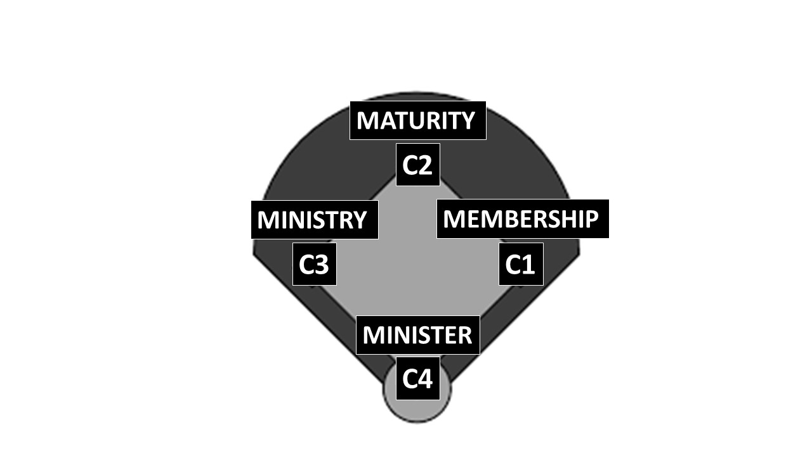

Go On To Second Base!

An Overview of Our Commitment Courses

Commitment Course - C1:

To lead people to Christ and membership at THE CORNERSTONE

Commitment Course- C2:

To grow people to spiritual maturity

Commitment Course- C3

To equip people with the skills they need for ministry

Commitment Course- C4

To enlist people to the mission of Sharing Christ

We’d Like To Get To Know You!

Name________________________Address__________________________
Phone_________________ Gender (M / F) Birthday_____________
o Single o Married o Widowed o Divorced
My occupation is______________Business______________
I have the following expertise_____________________________________

How did you start attending Cornerstone?
Friend___________ Family___________ Walkin_________
Personal Search / Internet__________ Other____________

Have you been part of any church before? Y / N

I have been active in the following churches in the past:
Yrs Involved Name of Church Location

Member? Ministry?
Y / N

How would you describe your relationship to Christ?
o Seeker/curious o I’m not sure what I believe
o New Christian o Committed Christian
o I’ve been a Christian for a while, but I want to grow closer

Information of Family Members
Married ( Y / N ) Spouse’s Name_____________
Children ( Y / N ) Child(ren) Name_______________________________
Do they attend THE CORNERSTONE? ( Y / N )

